Tiny Homes and Tiny Home Communities

The "tiny house" movement is a description for the architectural and social movement that advocates living simply in small homes. The definition of a tiny home is subjective, but generally speaking, it's a home between 100 and 400 square feet, either on wheels or a foundation.

Current Status | Placer County | Nevada County | Town of Truckee
Policy in Place | No policy, but tiny homes are allowed if they meet building code requirements. | No policy, but tiny homes are allowed if they meet building code requirements. | No policy, but tiny homes are allowed if they meet building code requirements.
On Permanent Foundation | Tiny Homes are allowed if the structure is:  - designed to meet site specific snow, wind, flood plain, wildfire hazard and other requirements;  - designed with at least one egress window;  - a building permit is obtained; and,  - all other building and zoning requirements have been met. | Tiny Homes are allowed if:  - the structure is not a recreational vehicle or manufactured/factory-built;  - meets building code standards such as minimum energy requirements, room dimensions, ceiling heights, sanitation, egress, etc.; and,  - a building permit is obtained. | Small Homes can be built on any single-family residence if:  - they meet building code requirements:  - meet snow load requirements; and,  - meet egress requirements.  HOAs may not allow tiny homes even if they meet Town of Truckee building code requirements.
Manufactured/ Pre-Fabricated | A tiny home on a foundation is allowed, the structure can either be pre-fabricated (manufactured/modular) or built on site. | Manufactured housing or factory-built housing is subject to federal standards and construction inspection by the Department of Housing and Community Development (HCD). Manufactured or factory-built housing may be approved for permanent habitation if a building permit is obtained and a certificate of occupancy issued for their installation in California. | If the tiny home has been altered at any time since original construction, evidence of alteration permits from HCD or HUD shall be presented to the Building Division when applying for a Building Permit for the tiny home.
On Wheels | A tiny home on wheels is considered a Recreational Vehicle (RV) and regulated by Zoning and Land Use and not the building code. There are restrictions on where and when they can be occupied. They are not considered permanent homes and cannot be occupied year-round. | Recreational vehicles and/or park model recreational vehicles are not permitted in California as places of permanent habitation. | Tiny Homes on wheels are considered mobile homes and are only allowed within areas zoned as mobile home parks. Mobile home parks are required to be permitted through the Town, but the maintenance of the parks is through the HCD.
Benefits of Tiny Homes as a Local Housing Solution
- Low cost: On average, Tiny Homes costs $25,000 in materials. They sell for about $35,000 to $80,000. In comparison, median sale price for single family home in Truckee is about $550,000.
- Can be built much faster than single-family homes. Tiny Homes can be built in 1 – 3 months while the average single-family home takes 7 months to build.
- Can provide relatively inexpensive temporary housing for seasonal employees on campgrounds and government owned land.
- Require much less lot space than the average single-family home.
- Opportunity to increase housing stock – either as rentals or ownership.
- More housing stock for locals increases the tax base and adds to economic activity in community from the workforce living in the community.
- Can be built as second dwelling units next to existing homes.
- Some municipalities are using Tiny Homes or Tiny Home Communities as housing for the homeless.
Other Communities where Tiny Homes have been a Successful Solution
Embracing a strategy of "Housing First"—the idea that addressing homelessness starts with giving folks a place to live—U.S. cities such as Dallas, Los Angeles, Syracuse, Nashville, Seattle, Austin, Detroit, and Portland have developed micro home communities for the low-income or homeless.
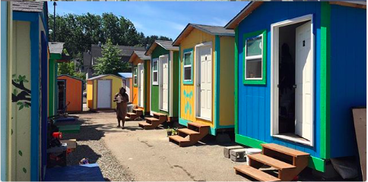
Othello Village—Seattle, Washington
Who: The city of Seattle, in collaboration with local non-profit Low Income Housing Institute
What: The third city-authorized homeless encampment hosts 28 96-square-foot tiny homes and 12 tents on platforms, which are intended as a short-term housing solution for up to 100 people, which are intended as a short-term housing solution for up to 100 people. The village shares a kitchen, shower trailer, donation hut, and security booth.
Cost: The city pays about $160,000 per year to supply water, garbage services, and counseling on-site. Donations from individuals, foundations, and other organizations have recently allowed all Othello Village tiny homes to install heat and electricity. Donations to the Low Income Housing Institute also fund the materials for the tiny homes, which cost about $2,200 per home; construction is mostly courtesy of volunteers.
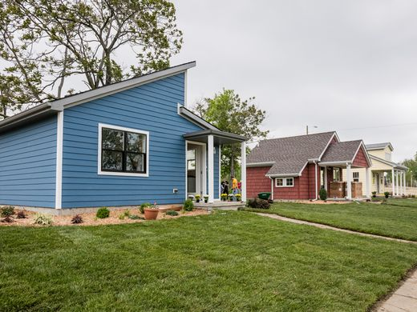
Current Status: In December 2016, Seattle mayor Ed Murray announced three new homeless encampment sites, two will house up 60 to 70 people in up to 50 tiny homes, while the third will have the same capacity in tents.

CASS Community Tiny Homes—Detroit, Michigan
Who: Local organization Community Social Services (CASS), focused on fighting poverty
Current What: A two-block stretch of 250 to 400-square-foot fully-equipped micro dwellings for the low-income population, including students, seniors, and the formerly homeless; tenants pay rent of between $250 and $400 a month on a rent-to-own model.
Cost: $1.5 million, so far funded by donations from local companies and organizations, including a $400,000 contribution from Ford.
Current Status: The first tiny home opened in early September 2016, while the latest batch of six homes was completed in May 2017. The goal is to build 25 homes in total.

Besides providing housing for the homeless and low income, ski areas such as Aspen, are starting to utilize tiny homes to house seasonal employees.

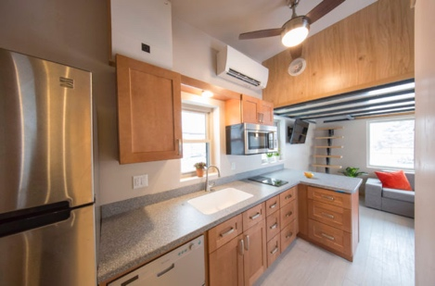
Tiny Home Trailer Coaches – Aspen, Colorado
Who: Aspen Skiing Company (SkiCo)
What: SkiCo built six "trailer coaches" on one of their campgrounds as an experiment to address affordable housing for their employees. Each tiny home can house 3 employees at the cost of $600/person.
Cost: $100,000 per home
Current Status: Following a successful trial run of the original six homes in 2017, SkiCo has ordered another 34 tiny homes that will be installed this summer, ready for employees to move in by the start of the winter season.

Challenges of Tiny Homes as a Local Housing Solution
- No clear definition of what is a tiny home. For the most part, tiny homes have no fixed, separate legal definition, which has made zoning and city regulations, as well as financing, sizable barriers to the industry’s growth.
- According to the California Department of Housing and Community Development, tiny homes on wheels generally are only allowed to be occupied in mobile home parks.
- If attached to a permanent foundation, only 1 is allowed per lot so this is not the optimal use of space if building multi-family housing is an option on the lot.
Status of New Policies/Ordinances Regarding Tiny Homes
- Placer County is currently researching regulations for tiny Homes to see if the County can reduce restrictions. Contact Person at Placer County: Shawna Purvines
- Nevada County and Town of Truckee are not currently working on new policies or ordinances regarding Tiny Homes.

^{vi} https://www.curbed.com/2017/7/18/15986818/tiny-house-zoning-adu-affordable-housing
http://tinyhousegiantjourney.com/2016/03/15/tiny-house-cost/
http://eyeonhousing.org/2015/08/how-long-does-it-take-to-build-a-single-family-home/
https://www.curbed.com/maps/tiny-houses-for-the-homeless-villages
http://www.powder.com/stories/news/can-tiny-homes-solve-aspens-big-housing-crisis/

